📅 Weekly Session Plan: AI-Powered Software Development

💻 Week 1: AI Agent vs. Human Developer Challenge
Component | Activity (2-3 Hours) | Notes
I. Introduction & Challenge | AI Awareness Session: Introduce the concept of AI Coding Agents (e.g., Code Agents in IDEs, Qwen CLI). | Focus on how AI speeds up boilerplate code.
II. The AI Build | Build the "Room Rent Manager" Web App: Use the Coding Agent IDE with a single prompt to generate the Frontend, Backend, and DB Schema. | Goal: App built and running in under 1 hour.
III. Comparison & Discussion | Analysis Session: Compare the AI build with traditional development:
 | * Time: AI (e.g., 1 hour) vs. Human (e.g., 1-2 weeks for a single developer, or 3-5 days for a small team with a dedicated Arch/Dev/Test cycle). | AI excels at rapid prototyping and boilerplate.
 | * Resources: AI (1 tool, 1 prompt) vs. Human (1 Software Developer, 1 Architect, 1 Tester). | Highlight the resource and cost savings.
 | * Deployment Challenges: Discuss AI-generated code challenges: Hallucinations/Inaccuracies, lack of Architectural Depth, missing Security considerations, and Dependency issues. | Human oversight is critical for production.

🛠️ Week 2: Setting up the AI/Linux Environment
Component | Activity (2-3 Hours) | Notes
I. Installation Session | Install Coding Agent IDE (e.g., VS Code + Copilot/Harness AI Agent, or a dedicated Agent IDE) in Laptops. | Step-by-step guidance on setting up the necessary tools.
II. Booking App Selection | List 25 Booking-Related Apps (e.g., Calendly, Acuity, Airbnb, Picktime, SuperSaaS, etc.). Ask students to pick one and define its core features. | Focus on the features and user journey of their chosen app.
III. 1-on-1 Guidance | Guided Prompting: Students begin using the Coding Agent IDE to generate the Frontend, Backend, and DB Schema for their own chosen booking app based on their required features. | Goal: Every student has a running, basic version of their own booking app.

🐧 Week 3: Transition to Linux & Qwen CLI
Component | Activity (2-3 Hours) | Notes
I. Linux Environment Setup | Convert Windows to WSL (Windows Subsystem for Linux) with Debian Environment.

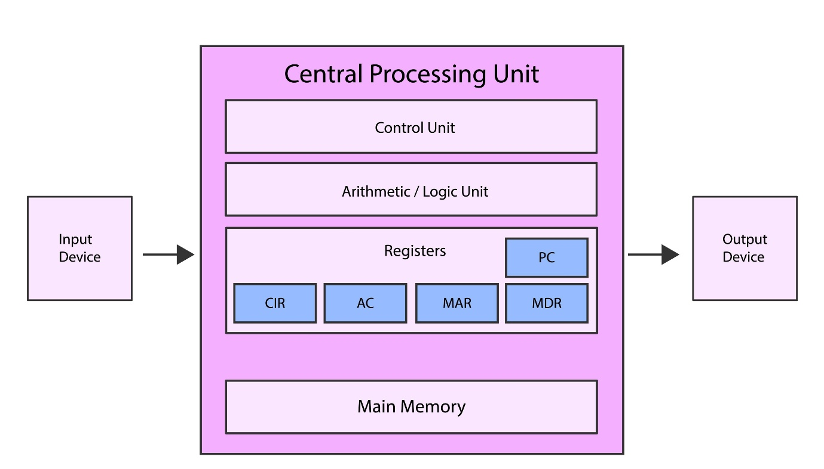
This is a crucial step for real-world development exposure. Guide students through installation and basic Linux commands (ls, cd, mkdir, sudo). | | II. Qwen CLI Installation | Install Qwen CLI AI Coding Agent Tool in the WSL Debian environment. | Explain the difference between an IDE-based agent and a CLI (Command Line Interface) agent, emphasizing the power of terminal-based automation. | | III. CLI AI Development | Replicate the App in WSL using Qwen CLI: Students use the Qwen CLI to regenerate or refine their booking app's code in the new Linux environment. | This gives them exposure to a different AI tool and a professional OS environment. |

💾 Week 4: Version Control and Repository Management
Component | Activity (2-3 Hours) | Notes
I. GitHub Setup | GitHub Account & Repository Creation: Guide each student to: | Hands-on Practice with Git fundamentals.
 | 1. Create a GitHub account.
 | 2. Create a new public repository for their booking app (e.g., my-booking-app).
 | 3. Add a basic README.md file. | Emphasize good documentation habits.
II. Git Workflow in WSL | Cloning & Pushing:
 | 1. Clone the new GitHub repository into their WSL Debian system. | git clone <repo_url>
 | 2. Copy their Qwen CLI-generated app code into the cloned local directory.
 | 3. Stage, Commit, and Push the code to their remote GitHub repository. | git add ., git commit -m "Initial AI generated code", git push
 | 4. Push the AI Prompt: Add a file containing the original prompt used to generate the code, and commit/push that as well. | Emphasize prompt engineering is part of the code asset.

🏗️ Week 5: Understanding and Debugging Architecture (The Human Touch)
Component | Activity (2-3 Hours) | Notes
I. Architecture Deep Dive | Grokking the App: Students use Grok-like steps (systematic, step-by-step learning/debugging) to manually understand the AI-generated code: | The first session where they don't rely on the AI to write the whole app.
 | 1. Analyze the DB Schema (tables, relationships).
 | 2. Map the Backend API (endpoints, functions).
 | 3. Understand how the Frontend integrates with the API.
II. Hands-On Debugging | The Error Resolution Cycle: | The most important session for real developer skills.
 | 1. Students intentionally break a part of their app (e.g., change an API path).
 | 2. They execute the broken code and analyze the error message (in the console/logs). | Teach them to read the stack trace.
 | 3. They use the Coding Agent IDE or Qwen CLI to get resolutions for the error. | The AI acts as a super-assistant/debugger, not the primary coder.
 | 4. They fix the code based on the resolution, test it, and commit/push the fix to GitHub from WSL. | Goal: End-to-end understanding of the development lifecycle (Code, Error, Debug, Fix, Commit).

✨ Week 6: UI/UX Design and AI Tool Exploration
Component | Activity (2-3 Hours) | Notes
I. UI/UX Design | Design using Google Stitch: Introduce the concept of professional UI/UX design.
 | 1. Students use Google Stitch (or a similar tool like Figma/AI) to create a good-looking, interactive, and well-navigated UI/UX for their booking app. | Focus on Visual Hierarchy and User Flow.
II. Backend/DB Refinement | Coding Agent Retraining: Use the new UI/UX as a prompt to refine the Backend and DB Schema using a Coding Agent tool (e.g., Qwen CLI) to match the new design requirements. | This simulates an iterative development cycle.
III. Multi-Agent Exposure | Successive AI Tool Runs: | The comparison continues: different AI tools for the same job.
 | 1. Successfully create the updated app using Qwen CLI.
 | 2. Successfully create the updated app using AI Studio (e.g., Gemini-powered tools).
 | 3. Successfully create the updated app using AI Antigravity (Placeholder for a third, unique agent/platform).

🧠 Week 7: Prompt Engineering Masterclass
Component | Activity (2-3 Hours) | Notes
I. Prompt Engineering Fundamentals | The Art of the Prompt: Teach students how to structure effective prompts for code generation: | Precision and Context are key.
 | * Context: (What the app does, existing code structure)
 | * Constraint: (Technology stack, security, styling rules)
 | * Clarity: (Specific function names, API endpoints, return types)
II. Advanced Prompting | Iterative Refinement Challenge: Students are challenged to use only prompts to implement a new feature (e.g., "Add user authentication" or "Implement a rating system") across their entire app. | They must achieve success by refining their prompt, not by manually writing the code.
III. Final Review | App Showcase & Feedback: Students present their final, fully committed and running booking app, discussing their biggest challenges with the AI agents and their most successful prompts.

